Scalable Medicare Claims Fraud Detection Using SQL-Based Feature Engineering and Machine Learning
Zayed M. Uddin¹, Abu Bakar Siddik Mishkat², Ulugbek Abdurakhmonov³, Sarika Rajeev⁴

¹Department of Mathematics and Computer Science, School of Arts & Sciences, CSU—Coppin State University, Baltimore, MD 21216, USA; Email: zayed.md.uddin273@gmail.com
²Department of Mathematics and Computer Science, School of Arts & Sciences, CSU—Coppin State University, Baltimore, MD 21216, USA; Email: mishkatfamily@gmail.com
³Department of Mathematics and Computer Science, School of Arts & Sciences, CSU—Coppin State University, Baltimore, MD 21216, USA; Email: ulugbekabdurakhmonov.tennis@gmail.com
⁴Department of Mathematics and Computer Science, School of Arts & Sciences, CSU—Coppin State University, Baltimore, MD 21216, USA; Email: srajeev@coppin.edu

1. Abstract
Healthcare fraud in Medicare always results in substantial losses of almost $100 billion annually and is getting hard to detect since the claims data are sophisticated and imbalanced. In this paper, we present a complete pipeline combining SQL feature store and supervised binary classification and unsupervised clustering on the Medicare dataset. We performed the unsupervised clustering only on the ground level fraudulent cases, and then we headed over classifying the fraudulent providers and clustered the high-risk providers into the fraud type groups. We cleaned the inpatient, outpatient and beneficiary tables stored in the PostgreSQL database. We also engineered the reusable provider and claim level features for the model training and evaluation. We included rule-based indicators for duplicate claims, upcoding and overcharging along with 30/90/365 days aggregates, distinct beneficiary counts and peer-normalized z-scores. We applied HDBSCAN algorithm for spotting patterns in inpatient and outpatient claims. For visualization, we used PCA to map out the data structure and association rule mining to label the clusters. We went through a bunch of supervised models and logistic regression ended up with PR-AUC around 0.73 and ROC-AUC around 0.94. Overall, computed features along with the supervised models and unsupervised clustering gave us a strong benchmark for evaluation. These also helped characterize different fraud types effectively.
Keywords: Medicare Fraud Detection, Insurance Fraud Types , Tree-based ensemble learning, Insurance Claims, HDBSCAN Fraud Clustering.

2. Introduction
2.1 Background and motivation
Healthcare fraud and abuse in large public insurance programs such as Medicare results in significant financial losses. This waste also eroded the trust in health systems [12], [14]. Medicare claims provide a lot of information regarding the patients, providers, diagnoses, procedures, deductibles, reimbursements for detection. However, those features are highly imbalanced and multidimensional. The fraudulent detection is sophisticated since fraud cases are rare among all the claims [3], [8], [12]. In such cases, rule-based systems are easy to deploy but are not great to automate the fraud detection and can generate high false-positive claims. These limitations have inspired comprehensive research into SQL-based feature engineering, machine learning and data mining approaches in healthcare fraud detection to invent hybrid approaches [3], [5], [8], [12], [14], [15].
2.2 Related Work
Recent studies document machine learning techniques for health insurance and Medicare fraud detection along with statistical models, ensemble learning, support vector machines, deep learning and hybrid pipelines [3], [8], [12], [14]. Logistic Regression, Extra Trees, CatBoost, Random Forests, LightGBM, XGBoost, all of these supervised models are trained on provider and claim level data and perform well when the ground level truth label exists. However, the efficacy of those methods is not notable as the label scarcity exists and fraud patterns evolve quickly [3], [5], [7], [8], [11]. K-means clustering and other density-based approaches discover different types of fraud across the claims and providers. Those detectors rely heavily on feature engineering which also yield high false positive cases and human verification is essential to reduce the rate of misclassification [1], [2], [6], [13], [15]. Association rule mining comes in handy for tagging those suspicious groups as several fraudulent types. It helps detect specifically whether the cluster represents duplicates, upcoding, overcharge or any other fraud patterns [5], [10]. Current research in this field emphasizes designing the hybrid models, supervised and unsupervised detectors within the end-to-end pipeline [3], [8], [12], [14], [15].

3. Methodology
3.1. Data sources and study design
We used the Medicare dataset from Medical Sphere (Open Source) which comes with 4 training and 4 test files. Both of them have provider, inpatient claims, outpatient claims, and beneficiary tables. The training provider table includes a PotentialFraud flag. Inpatient and outpatient tables contain each row with claim IDs, beneficiary IDs, provider IDs, dates, reimbursed amount, deductibles, and diagnosis/procedure codes. The inpatient table also has admission, discharge dates, and diagnosis-group fields. The beneficiary table contains basic patient information, demographics, and chronic condition indicators. We computed several statistical features, including mean, median, and z-scores, on payments, length of stay, alongside the aggregates such as total claims, total reimbursement amounts, and total number of unique beneficiaries on different timeframes (30/90/365 days) to classify the fraudulent providers. We utilized claims data for feature construction and performed unsupervised clustering on fraud-only claims. For supervised learning, we trained our models on 70% of the training data, and we kept 30% data for evaluation. We then applied the trained models on unlabeled test data to examine risk scores and labels for characterizing the provider-clusters.
3.2 Data cleaning and SQL feature store
All data processing was implemented in PostgreSQL using a layered design. We loaded raw CSV files into a staging schema with all fields as text and basic checks on structure and column counts. Cleaned data moved to a curated schema, where placeholder strings for missing values were converted to NULL and columns cast to appropriate types. We went through data processing steps to verify unique provider and beneficiary IDs. We made sure there were non-null values in all the features across the inpatient and outpatient tables. We also looked into valid foreign keys and non-negative payments, length of stay, and other numeric features. After handling those checks, we put together a mart schema where we had a fact table in place, along with feature tables focused on claims and providers. These tables contain details about the length of stay, code counts for diagnoses and procedures, duplicates, possible overcharges, peer-normalized z-scores, and 30/90/365-day aggregates.
3.3 Feature engineering and rule-based indicators
We derived features at both claim and provider levels. We implemented simple rules to capture duplicate billing, upcoding, overcharging, and other fraud patterns. We worked on reimbursed amount, deductible, length of stay, and counted the diagnosis and procedure counts at the claim level, depending on the type of patient. We also built rule indicators for exact or near duplicates by comparing for the same patient and provider within short timeframes. The cases with peer-normalized z-scores for payments, as well as the cases with the IQR threshold, were marked for overcharging. Additionally, we grouped claims across windows of 30, 90, and 365 days. This allowed us to get totals on claims and payments, as well as numbers of unique patients and diversity in diagnosis/procedure codes, and many other features. Lastly, we identified duplicates, upcoding, and overcharge cases and flagged them as suspicious claims.
3.4 Exploratory analysis and feature selection
After the initial setup of the SQL feature store was completed, we proceeded with the exploratory analysis and feature selection in Python, with the help of SQLAlchemy and pandas to load the claim and provider level feature tables from the database closely inspect the basic distribution of data. In order to assess skewness, long tails, and data errors for key variables such as reimbursed amounts, deductibles, and inpatient length of stay, we plotted histograms and boxplots, which confirmed the expected tailed patterns. We used statistical techniques such as interquartile ranges and median-based z-scores to identify extreme outlier claims, and then compared them with rule-based signals like overcharge indicators and inpatient claims involving short stays with unusually high payments. Additionally, we examined the correlations among engineered features using pairwise correlation coefficients and inflation factors to specify and remove highly collinear variables. In particular, we were interested in overlapping measures of recent reimbursement and claim volumes.
The results of the diagnostics allowed us to retain a compact, interpretable set of provider features. These features covered total and recent reimbursement as well as recent claim and unique beneficiary counts, code diversity, and peer-normalized reimbursement and length-of-stay z-scores, aggregated counts of duplicate, upcoding, and overcharge events.

3.5 Unsupervised fraud-only claim clustering
To better understand heterogeneity in fraudulent behavior, we clustered fraud-only claims. We first identified fraudulent providers from the training labels and extracted all associated inpatient and outpatient claims, building separate fraud-only tables. Using standardized engineered features—reimbursed amount, diagnosis and procedure counts, claim-level rule flags (duplicate and overcharge), and peer-normalized z-scores—we imputed missing values, scaled features, and applied HDBSCAN separately to inpatient and outpatient claims, choosing it for its ability to find clusters of varying size and density while treating atypical claims as noise. We tuned minimum cluster size and minimum samples, evaluated clustering quality with internal metrics and the noise fraction, and visualized structure via PCA projections colored by HDBSCAN cluster assignments. For each cluster, we produced “cluster cards” summarizing size, reimbursement levels, diagnosis/procedure multiplicity, and frequencies of rule flags, and we ran association rule mining within clusters to find frequent, high-lift diagnosis–procedure combinations, using these summaries and patterns to characterize distinct types of fraudulent claim behavior.
3.6 Supervised provider fraud classification
We used supervised learning to predict whether a provider is fraudulent based on aggregated claims features. Modelling was restricted to labeled training providers, with a stratified 70/30 provider-level split that preserved the fraud/non-fraud ratio. All provider-level features from the feature store were merged with the binary fraud label, and continuous variables were standardized using statistics from the training subset, then applied unchanged to the hold-out set. We compared multiple classifiers on the same feature set—logistic regression with elastic-net regularization, Random Forests, Extremely Randomized Trees, LightGBM, XGBoost, and CatBoost—using class weighting or imbalance-aware parameters to address the rarity of fraudulent providers. Hyperparameters were tuned via randomized search with five-fold cross-validation, optimizing area under the precision–recall curve (PR-AUC), and final models were evaluated on the 30% hold-out set using accuracy, precision, recall, F1, PR-AUC, and ROC-AUC. Instead of fixing a 0.5 cutoff, we chose the probability threshold that maximized F1 on the hold-out precision–recall curve. Logistic regression with elastic-net and class-balanced weighting emerged as the primary model, offering strong PR-AUC, competitive F1, and interpretable coefficients, while tree-based models served as baselines that confirmed most performance gains came from the engineered features rather than model complexity.
3.7 Provider fraud-type clustering
Beyond predicting whether a provider is fraudulent, we also sought to characterize distinct fraud patterns among high-risk providers. We defined a high-risk universe by combining all labeled fraudulent training providers with test providers whose logistic regression fraud scores exceeded a high threshold, then extracted the same standardized provider features used in supervised modeling (reimbursement levels, multi-window claims volumes, unique beneficiary counts, peer-normalized inpatient and outpatient z-scores, and rule counts for duplicates, upcoding, and overcharging). We applied HDBSCAN with Euclidean distance, a minimum cluster size of 10, and a small minimum samples value, allowing clusters of varying size and density and labeling atypical providers as noise. To examine structure, we projected providers into two principal components and colored points by cluster label, with noise in grey. For each cluster, we produced “cluster cards” summarizing size, labeled vs high-scored mix, and median utilization, payment, and rule-based features, interpreting them as fraud-type archetypes (e.g., high-revenue inpatient overchargers, high-volume outpatient overbillers).

4. Results
4.1 Data characteristics and exploratory analysis
The training data comprised 40,474 inpatient claims, 517,737 outpatient claims, 138,556 unique beneficiaries, and 5,410 labeled providers. As expected for Medicare billing, reimbursed amounts were highly skewed: most claims had modest payments, while a small fraction were costly, producing a low-payment bulk and a long right tail (Figure 1(a)). Inpatient and outpatient distributions differed: inpatient claims had higher medians and wider spread, and inpatient length of stay was skewed, confirming that inpatient services are costlier and more variable, whereas outpatient services drive volume (Figure 1(b)). We quantified high-cost extremity using interquartile-range and median absolute deviation rules, flagging but retaining a small set of potential outliers as possible fraud, abuse, or atypical cases. After cleaning, key variables such as reimbursed amounts and claim identifiers showed essentially no missingness. At the provider level, correlations and variance inflation factors (Figure 2) yielded a compact, interpretable feature set for subsequent unsupervised and supervised analyses.

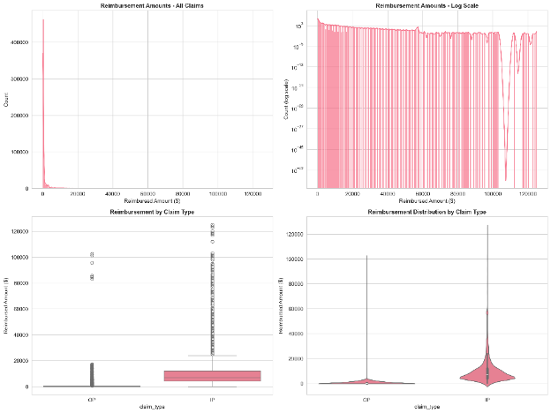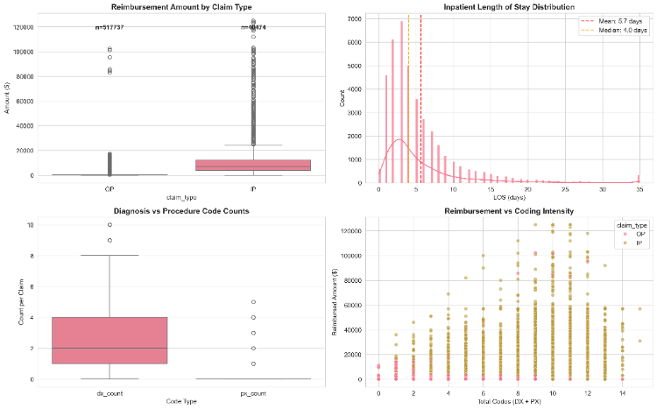
Figure 1. Distribution and comparison of claim reimbursements. (a) Histogram and density plots of reimbursed amounts for inpatient and outpatient claims, showing heavy right skew and a small number of very high-cost claims. (b) Boxplots of reimbursed amounts and, for inpatient claims, length of stay, highlighting distributional differences between claim types.
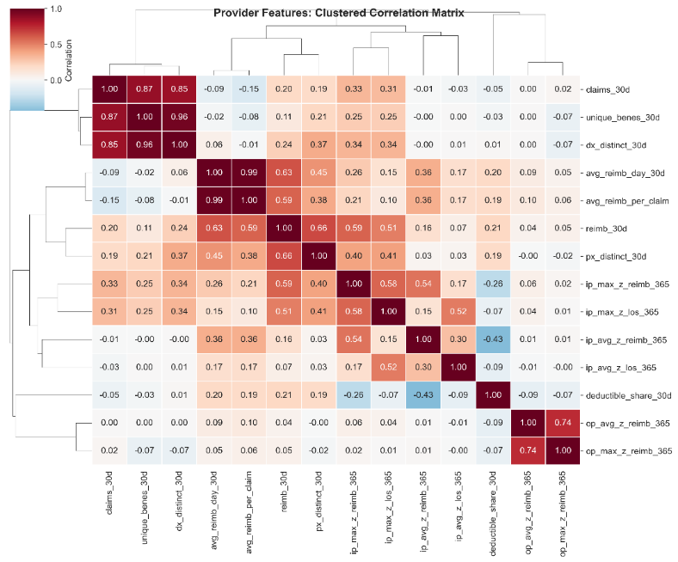
Figure 2. Correlation heatmap of provider-level features. Clustered Pearson correlation matrix for provider features, used to identify highly collinear variables and guide feature selection.
4.2 Unsupervised claim-level patterns among fraudulent claims
To explore heterogeneity in fraudulent behavior, we restricted the claim-level data to providers labeled as fraudulent, yielding 22,640 inpatient and 8,408 outpatient claims. After standardizing amounts, counts, rule flags, and peer-normalized z-scores, we applied HDBSCAN separately to inpatient and outpatient subsets. For inpatient claims, HDBSCAN produced several clusters and a noise set; PCA (Figure 3) showed a dense band with a few distinct groups, and cluster summaries showed a mix of moderate claims and high-payment long stays with elevated reimbursement/length-of-stay z-scores and some overcharge flags. Outpatient claims showed clearer structure: HDBSCAN yielded multiple clusters, and PCA (Figure 4) showed a core and some high-payment groups. Most outpatient clusters contained low- to moderate-paid claims, with one or two capturing higher-paid claims with positive reimbursement z-scores and overcharge indicators. Association rule mining within clusters (Table 1) highlighted narrow diagnosis-code sets in outpatient clusters and characteristic diagnosis–procedure pairs in high-payment inpatient clusters, informing rule-based feature design.
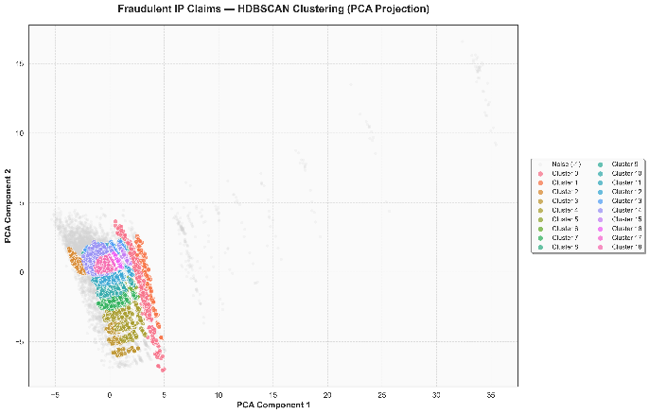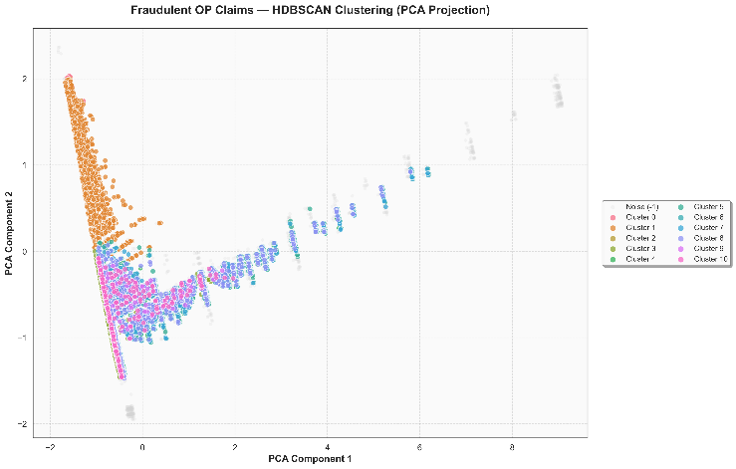
Figure 3–4. HDBSCAN clusters of fraudulent inpatient (left) and outpatient (right) claims. Two-dimensional PCA projections of standardized fraud-only claims are shown, with points colored by HDBSCAN cluster labels and noise points displayed in grey.
Claim Type | Cluster | Antecedents Str | Consequents Str | Support | Confidence | Lift
OP | 1 | 280+285 | 588 | 0.039 | 0.766 | 10.127
OP | 1 | 285+588 | 280 | 0.039 | 0.688 | 9.462
IP | 18 | 995 | 38 | 0.031 | 0.645 | 8.896
OP | 1 | V56 | 588 | 0.024 | 0.637 | 8.425
OP | 1 | 588 | 280 | 0.046 | 0.612 | 8.412
OP | 1 | 280 | 588 | 0.046 | 0.636 | 8.412
IP | 14 | 8154 | 715 | 0.031 | 0.863 | 7.415
IP | 13 | 7935 | 820 | 0.051 | 0.865 | 7.398
Table 1. Example diagnosis/procedure code patterns within claim clusters. Representative association rules for selected inpatient and outpatient HDBSCAN clusters, showing antecedent code sets, consequent codes, support, confidence, and lift, and illustrating recurring code combinations that are concentrated within specific fraud-only clusters.
4.3 Provider-level fraud classification performance
We evaluated supervised models for predicting provider fraud status using provider-level features. On the 30% hold-out subset of labeled providers, all models achieved ROC-AUC (≈0.93–0.94), indicating good discrimination; performance metrics are reported in Table 2. Logistic regression with elastic-net regularization and class-balanced weighting performed best, with PR-AUC ≈0.73, ROC-AUC ≈0.94, and, after threshold tuning, precision ≈0.59, recall ≈0.74, and F1 ≈0.66. Tree-based models (Random Forests, gradient boosting methods, CatBoost) achieved similar ROC-AUC but weaker PR-AUC or precision–recall trade-offs and did not surpass the interpretable linear model. Logistic regression fraud risk scores (Figure 5) placed most non-fraudulent providers near zero and fraudulent providers at higher values; the chosen threshold isolated a high-risk subset with elevated reimbursement, claim volumes, peer-normalized z-scores, and duplicate or overcharge flags. These scores were then applied to unlabeled test providers and used to define the high-risk provider universe for clustering in Section 4.4.
Model | Accuracy | Precision | Recall | F1 | PR_AUC | ROC_AUC
LogReg | 0.93 | 0.59 | 0.74 | 0.66 | 0.73 | 0.94
ExtraTrees | 0.91 | 0.53 | 0.74 | 0.61 | 0.70 | 0.93
CatBoost | 0.92 | 0.57 | 0.64 | 0.60 | 0.69 | 0.93
RandomForest | 0.93 | 0.62 | 0.61 | 0.61 | 0.69 | 0.93
LightGBM | 0.91 | 0.51 | 0.78 | 0.61 | 0.68 | 0.93
XGBoost | 0.91 | 0.51 | 0.78 | 0.61 | 0.68 | 0.93
Table 2. Supervised model performance on the provider hold-out set. Classification performance of logistic regression (elastic-net), Random Forests, ExtraTrees, LightGBM, XGBoost, CatBoost reported as accuracy, precision, recall, F1-score, area under the precision–recall curve (PR-AUC), and area under the ROC curve (ROC-AUC).
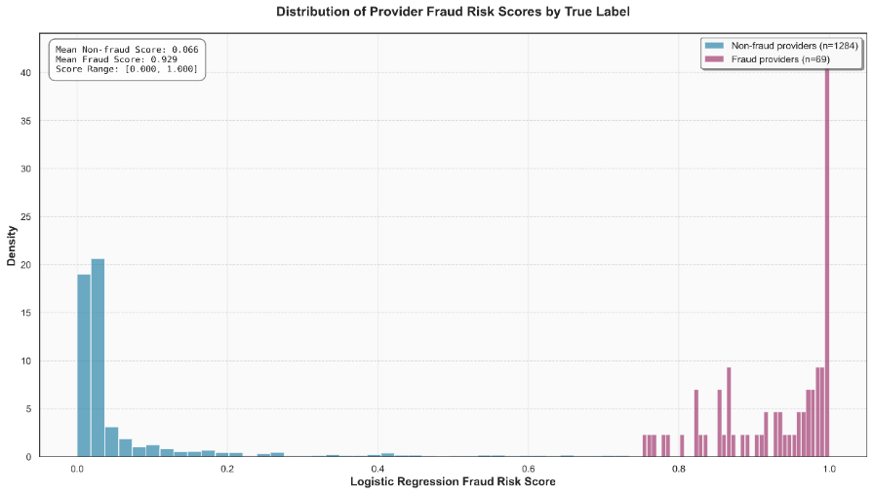
Figure 5. Distribution of provider fraud risk scores. Histogram or density plots of logistic regression fraud risk scores for labeled providers, stratified by true fraud label, illustrating separation between non-fraudulent providers (scores near zero) and fraudulent providers (scores shifted toward higher values).
4.4 Provider fraud-type clusters
To characterize provider-level fraud patterns, we defined a high-risk universe of 570 providers by combining labeled fraudulent training providers with test providers whose logistic regression fraud score exceeded a threshold, then applied HDBSCAN to standardized provider features. HDBSCAN identified four clusters and labeled 334 providers as noise, indicating many high-risk providers do not belong to any dense group. A PCA projection (Figure 6) shows compact regions for clusters and a diffuse cloud of noise. The largest cluster (Cluster 3, 180 providers) includes moderate-volume providers with reimbursement and inpatient activity and elevated inpatient reimbursement and length-of-stay z-scores but modest duplicate and overcharge counts. Cluster 1 (36 providers) comprises high-revenue providers with more extreme inpatient z-scores and signs of upcoding, an “inpatient overcharger” pattern. Cluster 0 and Cluster 2 (10 providers each) capture high-volume outpatient billers with duplicates and overcharge flags or large panels and small-ticket overbilling. Table 3 summarizes these archetypes.

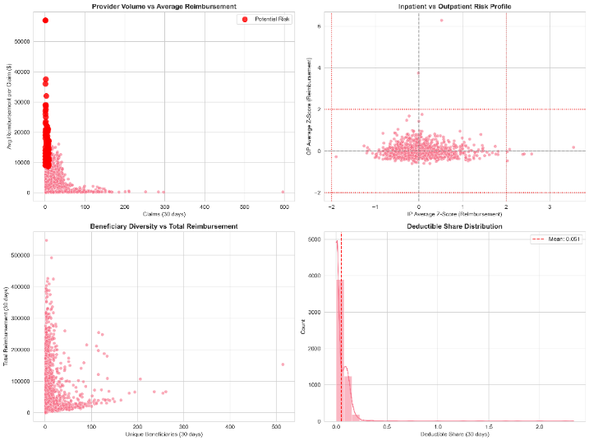
Figure 6. Clusters of high-risk providers. Two-dimensional PCA projection of standardized provider-level features for high-risk providers, colored by HDBSCAN cluster label, with noise providers shown in grey.
cluster | n_providers | n_train_fraud | n_test_highrisk | median_reimb_365d | median_claims_365d
0 | 10 | 10 | 0 | 252570 | 309
1 | 36 | 36 | 0 | 490880 | 140
2 | 10 | 10 | 0 | 390030 | 1336
3 | 180 | 180 | 0 | 210265 | 108
Table 3. Summary of provider fraud-type clusters. For each provider cluster identified by HDBSCAN, the table reports the number of providers, the fraction originating from labeled training frauds versus high-scored test providers, and median values of key features such as annual reimbursement, claim volume, peer-normalized z-scores, and counts of duplicate, upcoding, and overcharge flags.

5. Discussion/Conclusion
This work developed an end-to-end fraud analytics pipeline on Medicare-like claims that combines SQL-based feature engineering, supervised provider classification, and unsupervised pattern discovery at both claim and provider levels. This integrated, multi-paradigm design aligns with recent surveys and position papers that argue for combining rules, supervised models, and unsupervised anomaly detection rather than relying on single-model solutions [3], [8], [12], [14]. Our finding that a regularized logistic regression model can match more complex tree-based and neural models is consistent with evidence that “classical” approaches remain strong baselines for healthcare fraud when supported by robust feature engineering [3], [8], [11], while deep learning offers additional gains in some insurance settings [7]. The use of HDBSCAN, clustering, and association rules to characterize heterogeneous fraud patterns at the claim and provider level mirrors contemporary work on unsupervised anomaly detection and multivariate clustering in health insurance data [1], [2], [5], [13], [15].
Overall, the results suggest that carefully engineered SQL features, interpretable linear models, and targeted unsupervised analyses can deliver competitive provider-level fraud detection while yielding meaningful fraud-type archetypes. Rather than proposing a single novel algorithm, our contribution is to demonstrate how supervised risk scoring, rule-based indicators, and unsupervised clustering can be orchestrated into a transparent, reproducible pipeline that reflects current best practices and research directions in healthcare fraud analytics [3], [8], [12], [14].
Author Contributions
Zayed Uddin: conceptualization, resources, data analysis, project organization, validation, writing– original draft, writing– review and editing. Md Mishkat: conceptualization, validation, writing– original draft, writing– review and editing. Ulugbek Abdurakhmonov: validation, writing draft, review and editing.
Conflicts of Interest
The authors declare no conflicts of interest.
Sources of Funding
All the authors declare to have received no financial support or sponsorship for this study.

References:
[1] M. Bairy, B. Muniyal, and N. P. Shetty, “Enhancing healthcare data integrity: Fraud detection using unsupervised learning techniques,” Int. J. Comput. Appl., vol. 46, no. 11, pp. 1006–1019, 2024, doi: 10.1080/1206212X.2024.2408262.
[2] H. De Meulemeester, F. De Smet, J. van Dorst, E. Derroitte, and B. De Moor, “Explainable unsupervised anomaly detection for healthcare insurance data,” BMC Med. Inform. Decis. Mak., vol. 25, art. 14, 2025, doi: 10.1186/s12911-024-02823-6.
[3] A. du Preez, S. Bhattacharya, P. Beling, and E. Bowen, “Fraud detection in healthcare claims using machine learning: A systematic review,” Artif. Intell. Med., vol. 160, art. 103061, 2025, doi: 10.1016/j.artmed.2024.103061.
[4] G. Saldamli et al., “Health care insurance fraud detection using blockchain,” in Proc. 7th Int. Conf. Softw. Defined Syst. (SDS), 2020, pp. 145–152, doi: 10.1109/SDS49854.2020.9143900.
[5] Z. Hamid, F. Khalique, S. Mahmood, A. Daud, A. Bukhari, and B. Alshemaimri, “Healthcare insurance fraud detection using data mining,” BMC Med. Inform. Decis. Mak., vol. 24, art. 112, 2024, doi: 10.1186/s12911-024-02512-4.
[6] Kanksha, A. Bhaskar, S. Pande, R. Malik, and A. Khamparia, “An intelligent unsupervised technique for fraud detection in health care systems,” Intell. Decis. Technol., vol. 15, no. 1, pp. 127–139, Feb. 2021, doi: 10.3233/IDT-200052.
[7] P. A. Kumar and S. Sountharrajan, “Insurance claims estimation and fraud detection with optimized deep learning techniques,” Sci. Rep., vol. 15, art. 27296, 2025, doi: 10.1038/s41598-025-12848-0.
[8] N. Kumaraswamy, M. K. Markey, T. Ekin, J. C. Barner, and K. Rascati, “Healthcare fraud data mining methods: A look back and look ahead,” Perspect. Health Inf. Manag., vol. 19, no. 1, p. 1i, 2022.
[9] Q. Liu and M. A. Vasarhelyi, “Healthcare fraud detection: A survey and a clustering model incorporating geo-location information,” in Proc. 29th World Continuous Auditing and Reporting Symp. (WCARS), Brisbane, Australia, Nov. 21–22, 2013.
[10] I. Matloob, S. A. Khan, and H. U. Rahman, “Sequence mining and prediction-based healthcare fraud detection methodology,” IEEE Access, vol. 8, pp. 143256–143273, 2020, doi: 10.1109/ACCESS.2020.3013962.
[11] E. Nabrawi and A. Alanazi, “Fraud detection in healthcare insurance claims using machine learning,” Risks, vol. 11, no. 9, art. 160, 2023, doi: 10.3390/risks11090160.
[12] K. Razzaq and M. Shah, “Next-generation machine learning in healthcare fraud detection: Current trends, challenges, and future research directions,” Information, vol. 16, no. 9, art. 730, 2025, doi: 10.3390/info16090730.
[13] L. Settipalli and G. R. Gangadharan, “WMTDBC: An unsupervised multivariate analysis model for fraud detection in health insurance claims,” Expert Syst. Appl., vol. 215, art. 119259, 2023, doi: 10.1016/j.eswa.2022.119259.
[14] A. Y. B. R. Thaifur, M. A. Maidin, A. I. Sidin, and A. Razak, “How to detect healthcare fraud? A systematic review,” Gac. Sanit., vol. 35, suppl. 2, pp. 441–449, 2021, doi: 10.1016/j.gaceta.2021.07.022.
[15] M. C. Massi, F. Ieva, and E. Lettieri, “Data mining application to healthcare fraud detection: A two-step unsupervised clustering method for outlier detection with administrative databases,” BMC Med. Inform. Decis. Mak., vol. 20, art. 160, 2020, doi: 10.1186/s12911-020-01143-9.

